**ACTIVITY #1a**

The figure below shows the approximate lifespan of nine different cell types.

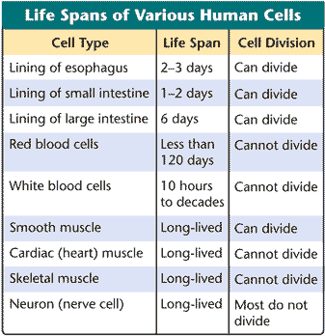

1. Based on the data, in what ways might injuries to the heart and spinal cord be similar? Provide evidence and reasoning to support your claim.
2. How might injuries to the lining of your small intestine compare to those you described above? Provide evidence and reasoning to support your claim.
3. If cancer cells were added to the table, predict what would be written under “Life Span” and “Cell Division” columns.
4. How does the above data help to explain the following side effects that accompany chemotherapeutic drugs that are administered to cancer patients?

* Hair loss
* Nausea and vomiting
* Appetite changes
* Constipation or diarrhea
* Mouth, tongue, and throat problems such as sores and pain with swallowing
* Skin and nail changes

**ACTIVITY #1b**

The figure below shows the approximate lifespan of nine different cell types.



1. How would injuring the neurons in your brain compare to injuring the cells that line your small intestine. Use the SEE method to respond.
2. If cancer cells were added to the table, predict what would be written under “Life Span” and “Cell Division” columns.
3. Two of the side-effects of chemotherapeutic drugs that are given to patients with cancer include sores in their esophagus and vomiting. How does the above data help to explain these side effects?

**ACTIVITY #2a**

Scientists measured cyclin levels in clam egg cells as they carried out their first few mitotic divisions after fertilization. The data are shown in the graph below.

Cyclins are continually produced and destroyed within cells and provide the cell with signals to enter different phases of the cell cycle.

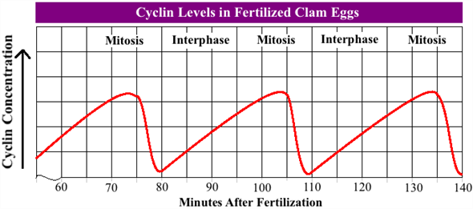

1. Which takes more time to occur: cyclin production or cyclin destruction? Explain this difference in terms of the cell cycle.
2. Are cyclins internal or external regulators? Explain.
3. Are cyclins coded for by tumor suppressor genes or proto-onco genes? Explain.
4. Predict what the impact on the cell cycle would be if:
   1. Cyclin levels were to remain after cytokinesis.
   2. The enzymes that produce cyclins within the cell are not activated.

**ACTIVITY #2b**

Scientists measured cyclin levels in clam egg cells as they carried out their first few mitotic divisions after fertilization. The data are shown in the graph below.

Cyclins are continually produced and destroyed within cells. Cyclin production signals cells to enter mitosis, while cyclin destruction signals cells to stop dividing and enter interphase.



1. How long does cyclin production last during a typical cell cycle in a fertilized clam egg?
2. During which part of the cell cycle does cyclin production begin?
3. How quickly are cyclins broken down?
4. Predict what would happen to the cell cycle if the enzyme that makes cyclins is not functioning properly.

**ACTIVITY #3a**

How are the growth of a tumor and a scrape on your knee similar? How are they different?

**ACTIVITY #3b**

Create a table or Venn diagram in which you compare and contrast the growth of a tumor to a scrape on your knee.